Title: | <Door Control Unit>  SW Component < WindowControlApp>

History
Issue status  (Index) | Maturity/Date  (draft/invalid/valid)  (dd-mmm-yyyy) | Author  Department | Check/Release  Department | Description
1.0 | Draft  2-Feb-20 | Raul Sanchez | Ruben | Creation of the document

Table of Contents
1 Purpose 3
2 Definitions and abbreviations 3
3 Realization constraints and targets 3
4 SW Conceptual design 3
5 SW Component internal breakdown 4
5.1 Functional Decomposition 4
5.2 Function <Type> <function name> (type par 1, .., type par n) 5
5.3 Function <Type> <function name> (type par 1, .., type par n) 5

Purpose
This document has the purpose of provide details on the design of WindowControlApp software component

Definitions and abbreviations
Definitions
N/A | N/A

Abbreviations
CAN Controller Area Network
DCU Door Control Module
References
N° | Document name | Reference
1 | SW Architecture description

Realization constraints and targets
This SW component is designed to perform window control logic of DCU and demonstrate internal functionality of this component

SW Conceptual design
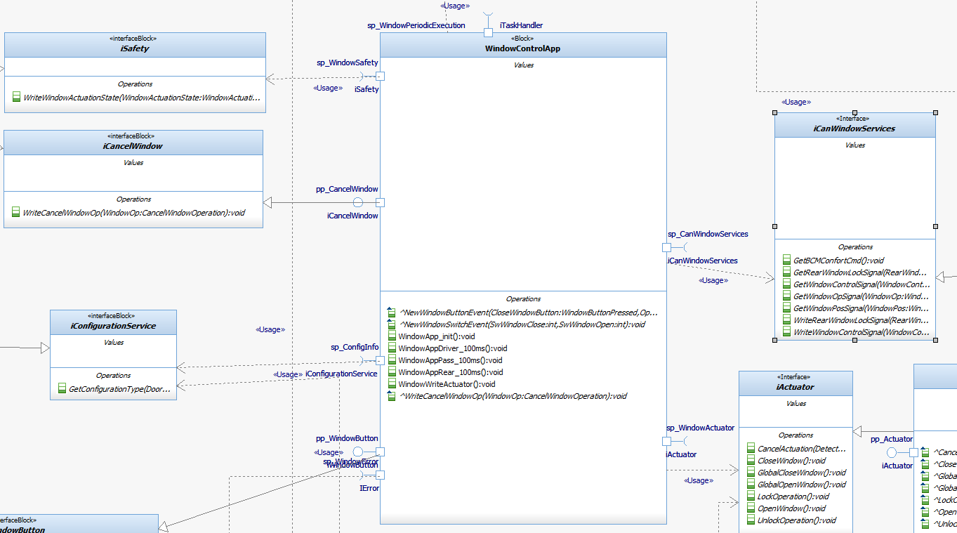

SW Component internal breakdown

Functional Decomposition

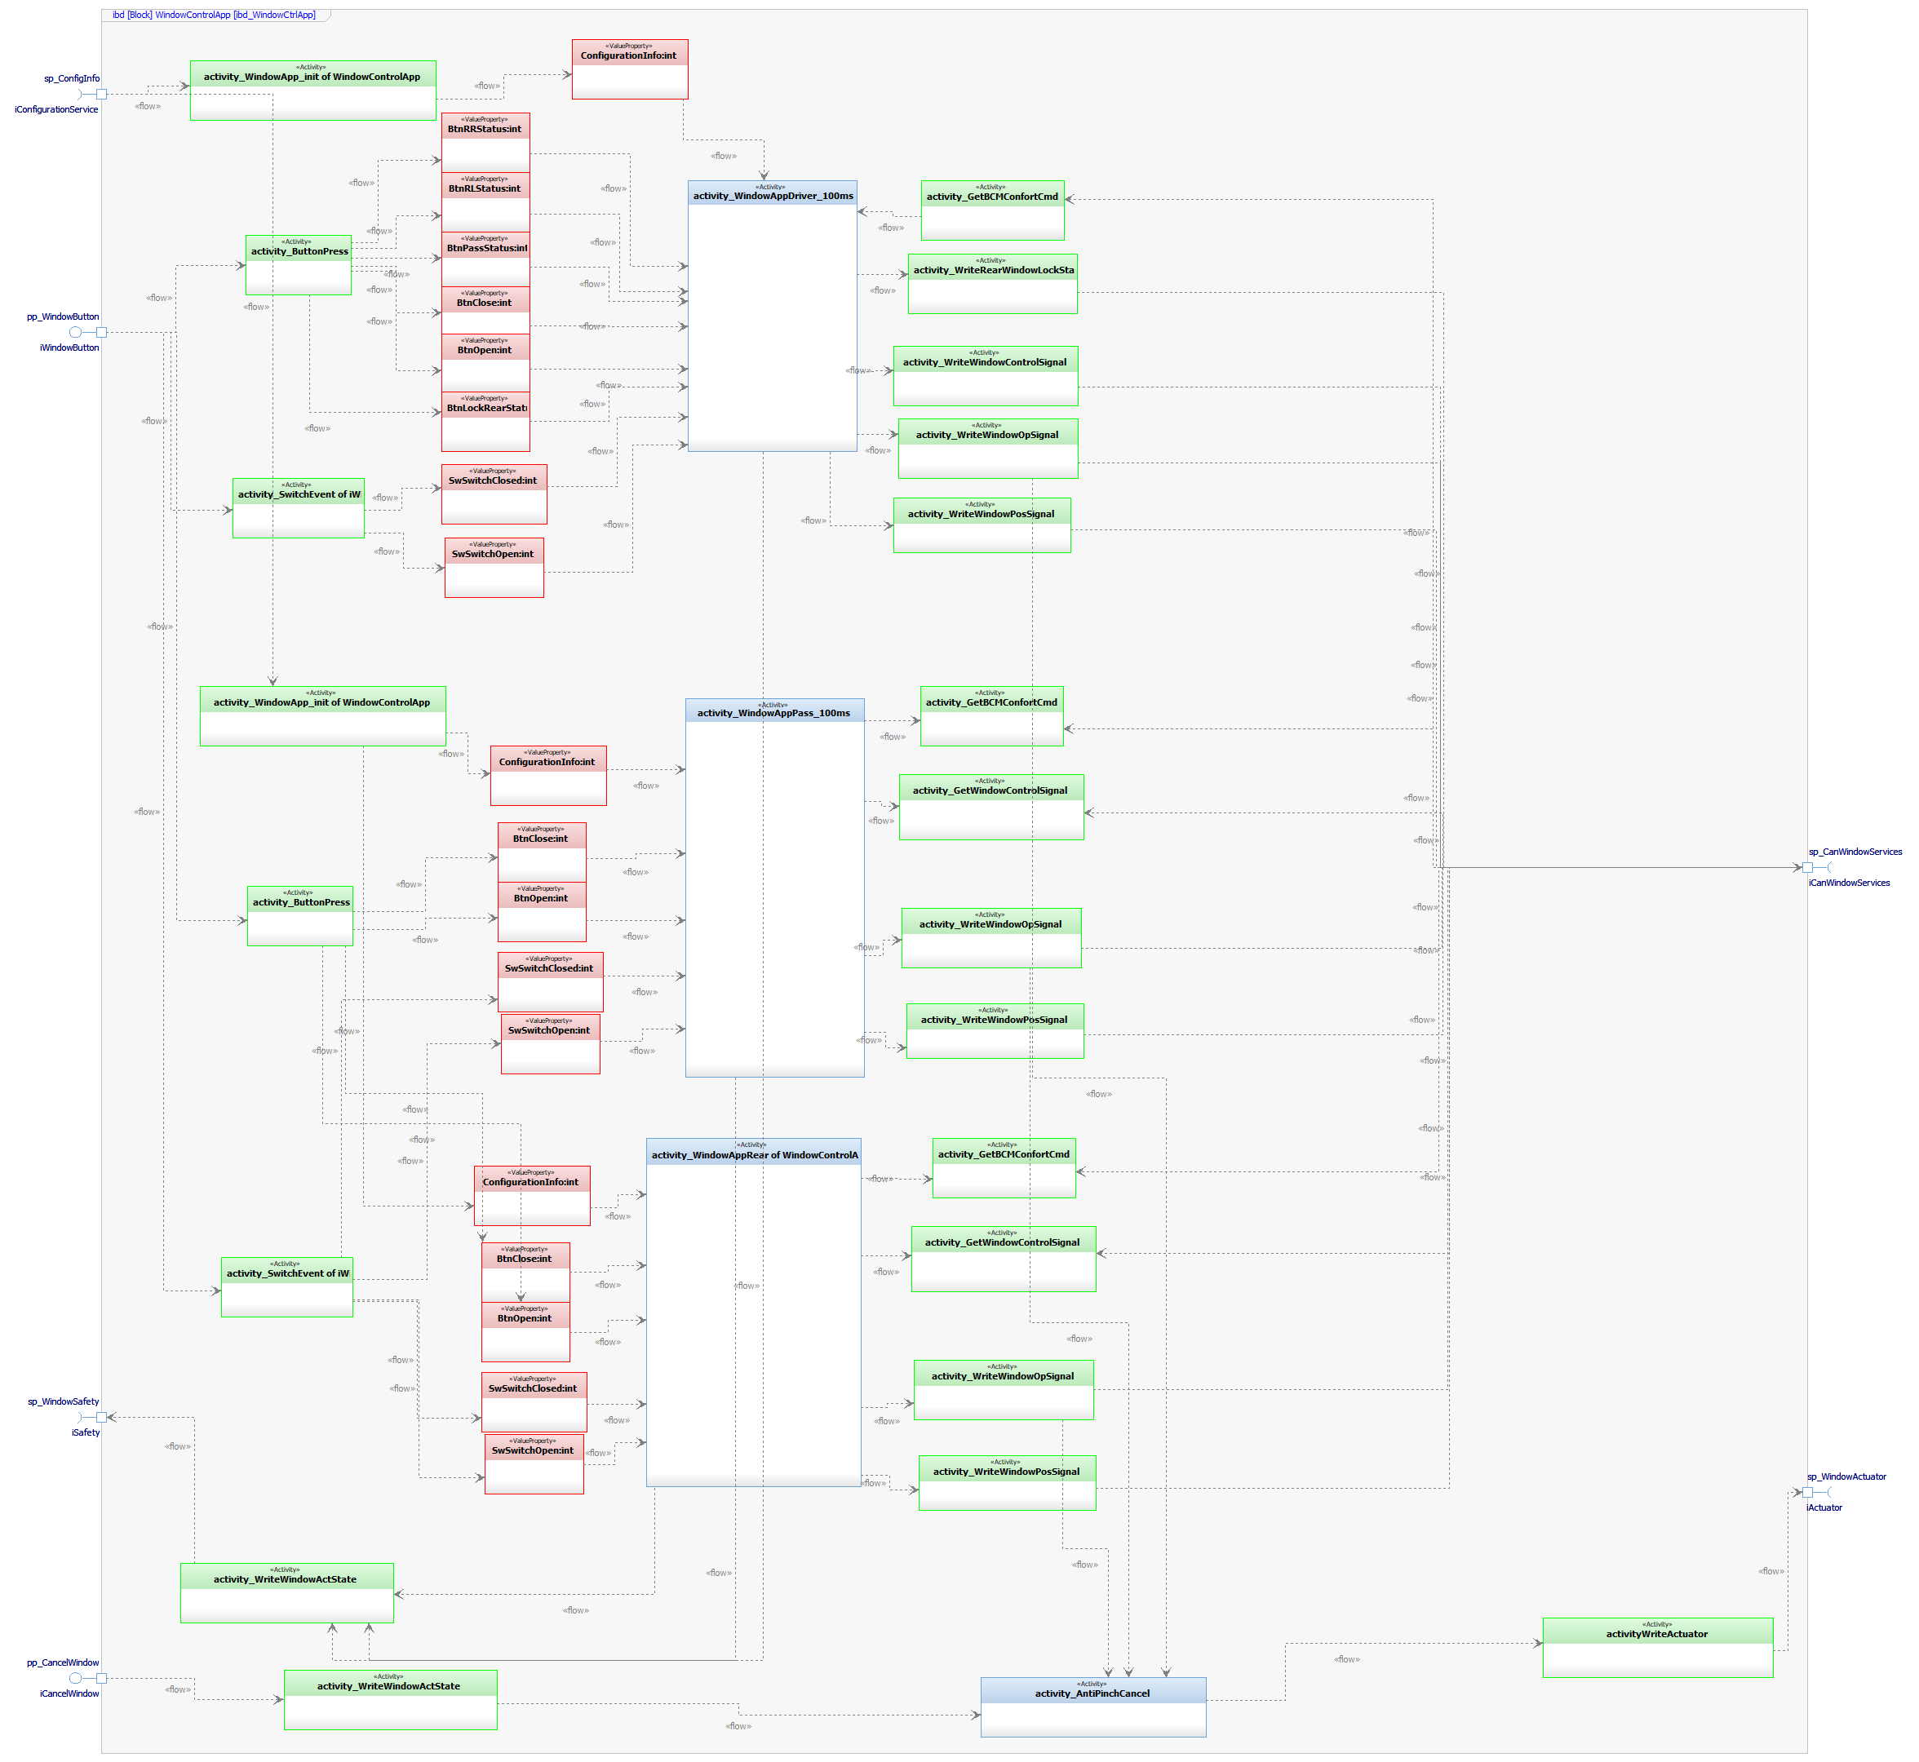
Function Description and Dynamic Behavior

Function <Void> <WindowApp_init()> ()

Description | Function for init Window Application Task
Parameter 1  <input| output| inout> | N/A
Parameter 2..n | N/A
Return Value | N/A
Precondition | Configuration of DCU ready
Post condition | Bring the correspondent piece of software depending on the configuration
Error Conditions | N/A
Requirements | N/A

Dynamic Behavior
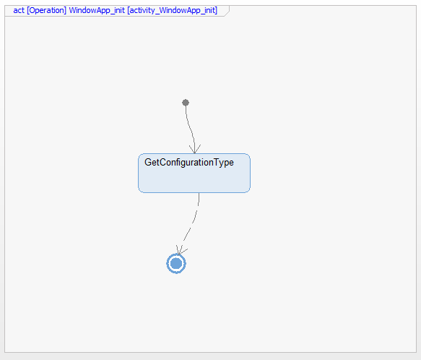

Function <Void> <WindowAppDriver_100ms> (Button Pressed)
Description | This function performs manual and remote logic of the wind ow control for driver door
Parameter 1  <input| output| inout> | Button Pressed
Parameter 2..n | N/A
Return Value | Window_actuation_task
Precondition | Function called only if door is configured as DRIVER
Post condition | If is valid send mode operation for window
Error Conditions | If a window button is stucked or Solenoid is damaged
Requirements | review Traceability Matrix

Dynamic Behavior

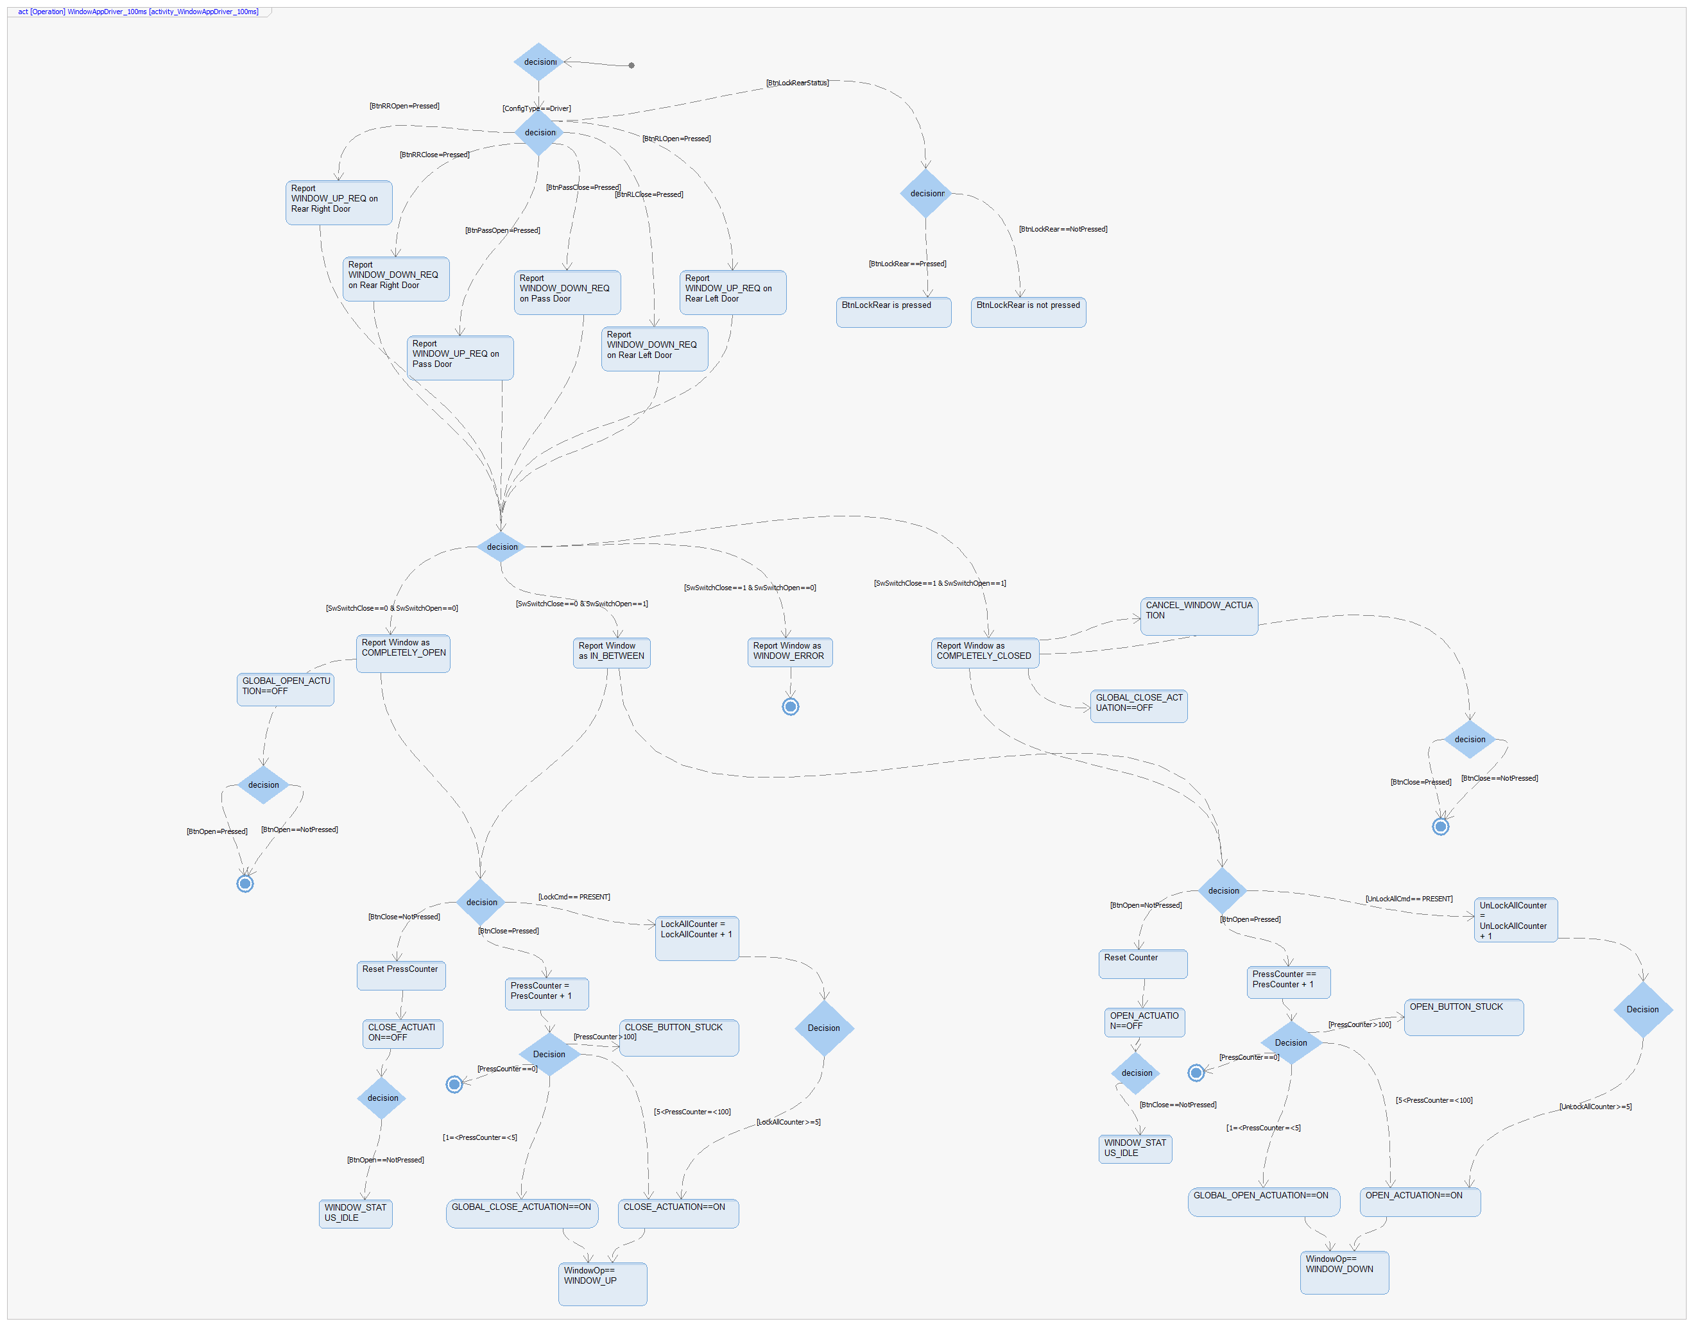

Function <Void> <WindowAppPass_100ms> (Button Pressed)
Description | This function performs manual and remote logic of the wind ow control for passenger door
Parameter 1  <input| output| inout> | Button Pressed
Parameter 2..n | N/A
Return Value | Window_actuation_task
Precondition | Function called only if door is configured as Passenger
Post condition | If is valid send mode operation for window
Error Conditions | If a window button is stucked or Solenoid is damaged
Requirements | review Traceability Matrix
Dynamic Behavior
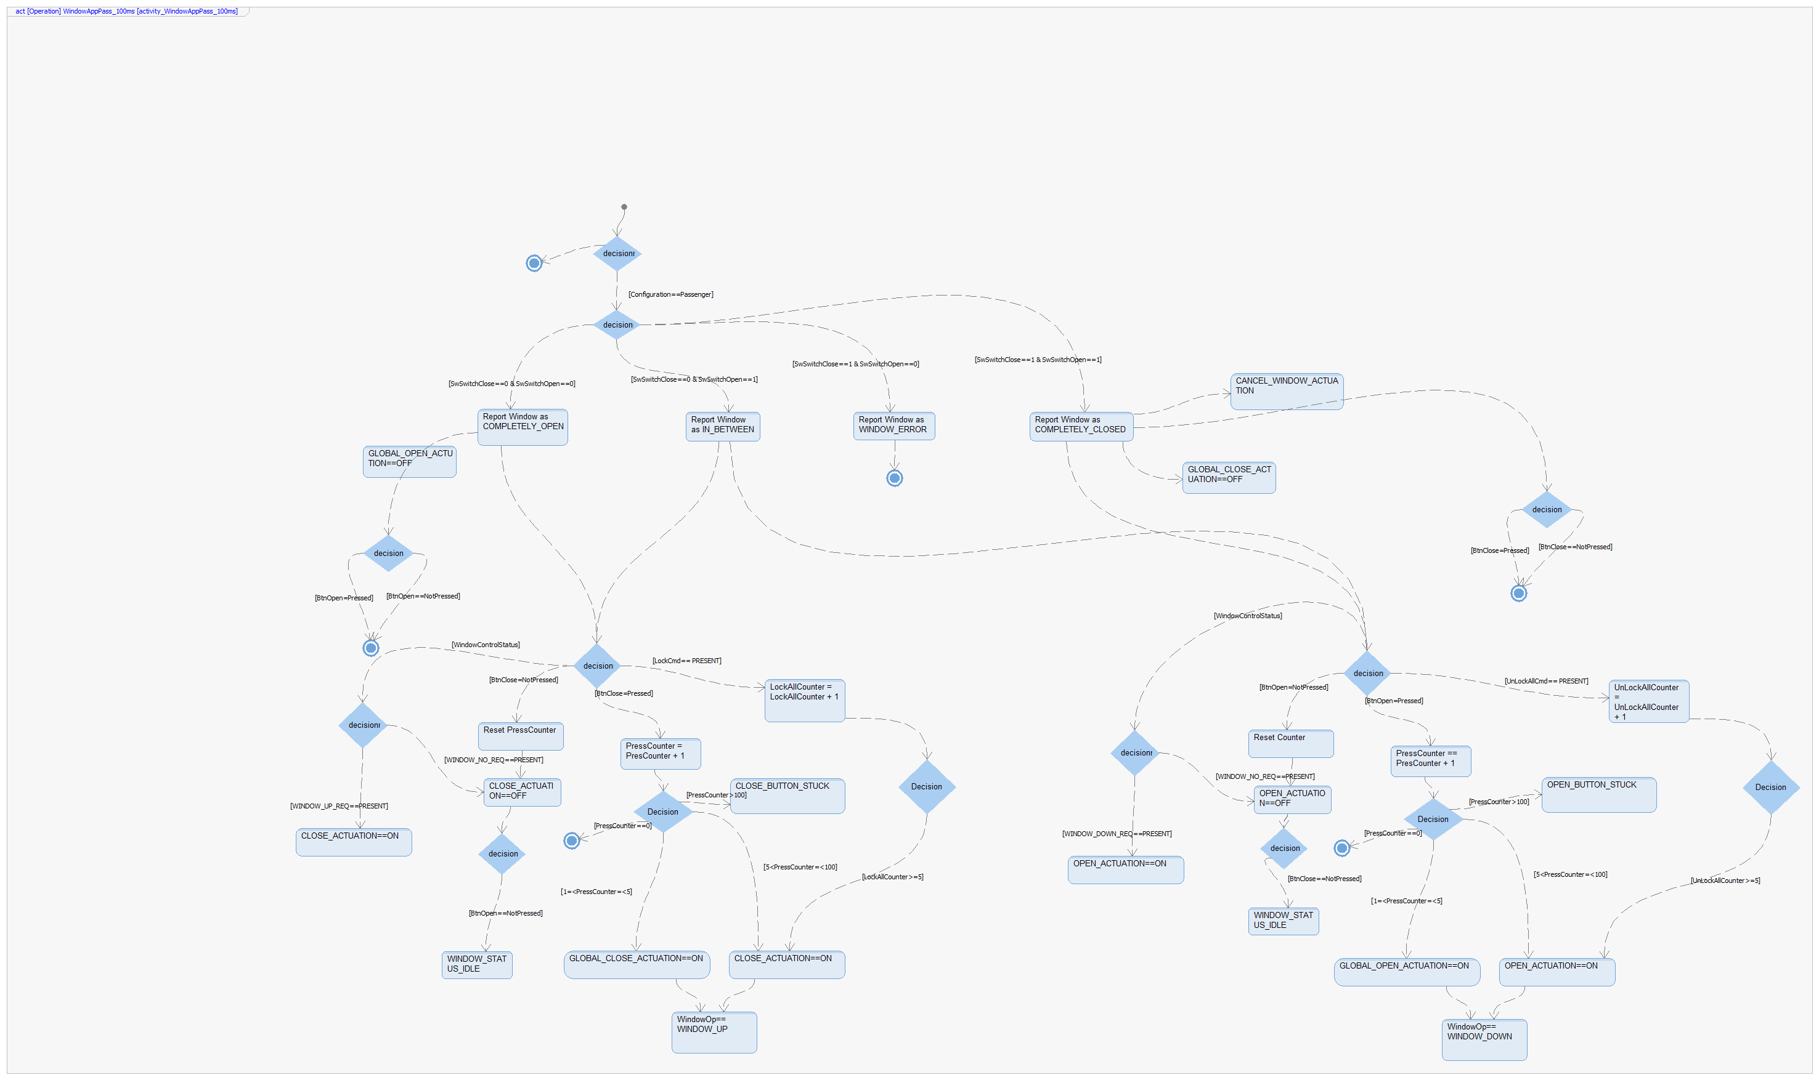

Function <Void> <WindowAppRear_100ms> (Button Pressed)
Description | This function performs manual and remote logic of the window control for rear left and rear right door
Parameter 1  <input| output| inout> | Button Pressed
Parameter 2..n | N/A
Return Value | Window_actuation_task
Precondition | Function called only if door is configured as Rear Right and Rear Left
Post condition | If is valid send mode operation for window
Error Conditions | If a window button is stucked or Solenoid is damaged
Requirements | review Traceability Matrix
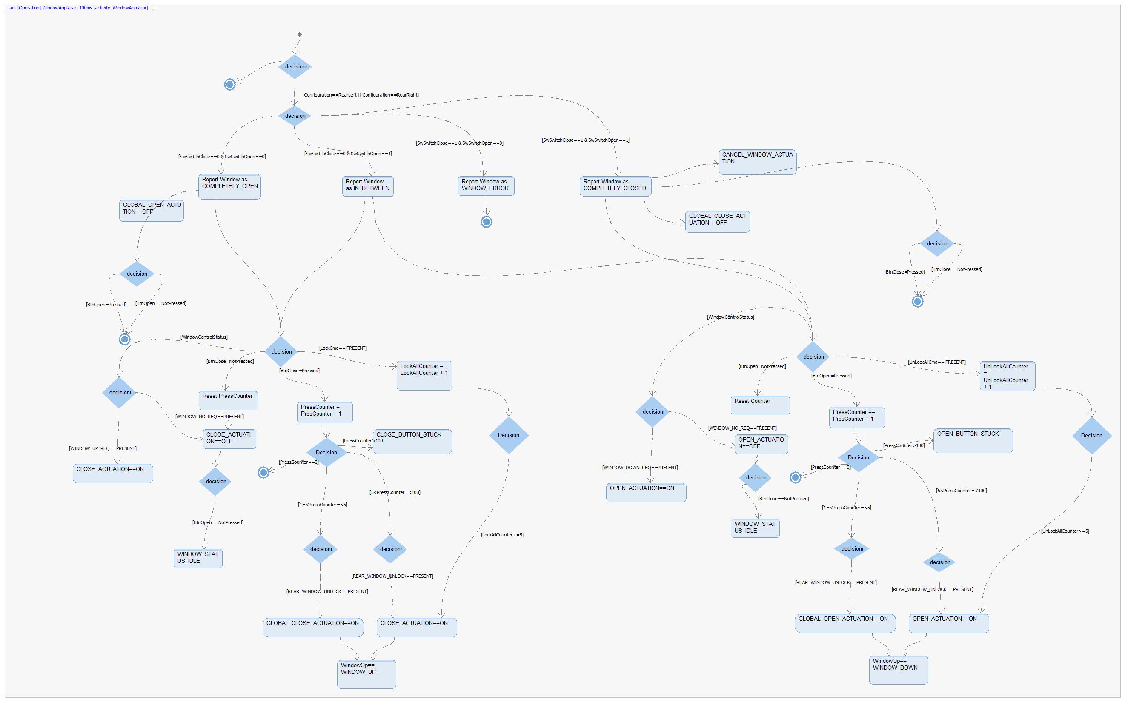

Interface <Void> <Button_pressed> (Button Event)
Description | This function check if theres a button event
Parameter 1  <input| output| inout> | Button Event
Parameter 2..n | N/A
Return Value | ButtonPressed
Precondition | N/A
Post condition | Send an button event
Error Conditions | N/A
Requirements | N/A
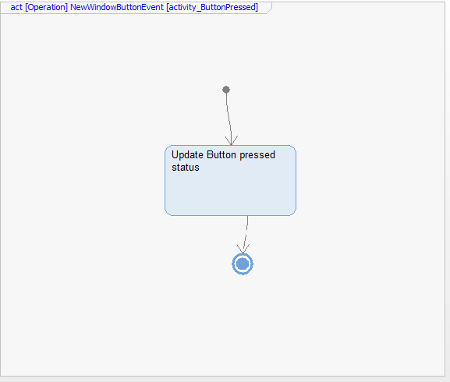

Interface <Void> <Switch_pressed> (Switch Event)
Description | This function check if theres a switch event from the window limits
Parameter 1  <input| output| inout> | Switch Event
Parameter 2..n | N/A
Return Value | ButtonPressed
Precondition | N/A
Post condition | Send an switch event
Error Conditions | N/A
Requirements | N/A
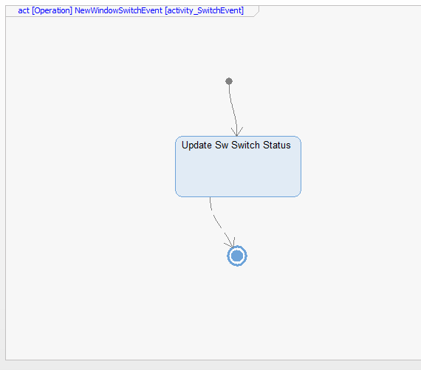

Interface <Void> <CancelWindowEvent> (Cancel Event)
Description | This function check if theres a cancel event from antipinch sensor
Parameter 1  <input| output| inout> | Switch Event
Parameter 2..n | N/A
Return Value | CancelActuation
Precondition | N/A
Post condition | Send an cancel actuation if theres a antipinch event
Error Conditions | N/A
Requirements | N/A
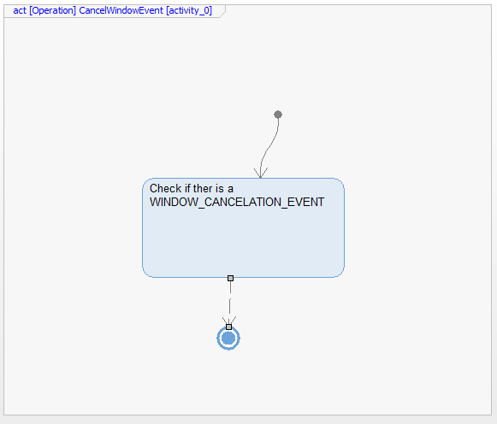

Function <Void> <AntiPinchCancel (AntiPinchEvent)
Description | This function performs logic of the Antipinch application when there is an antipinch event
Parameter 1  <input| output| inout> | AntiPinchEvent
Parameter 2..n | N/A
Return Value | Window_actuation_task
Precondition | If there is a window actuation task
Post condition | If there is an Antipinch event send CANCEL_WINDOW_ACTUATION signal
Error Conditions | N/A
Requirements | review Traceability Matrix
